**Experiment No. 6b**

**Title :** Implementation of Binary Tree Traversal.

**Problem Statement :** Write a C++ code to implement binary tree traversal with following functionalities

Insert() ,Inorder() ,Preorder() ,Postorder()

**Algorithm:**

**Step 1:** Start

**Step 2:** Create a structure binary_tree_node with left and right pointer of the same structure and a data variable

**Step 3:** Create a class bonary_tree with the root as instance of structure binary_tree_node and point it to NULL and create a function isempty() which check for is empty of tree

**Step 4:** Create class function insert() to insert a value into the binary tree which checks for root node existence and if no new node will be root node else the data is compared with the node data and put to left or right .

**Step 5:** Create a inorder() function which traverse from left node to parent and then to right most node and this continues till root node

**Step 6:** Create a preorder() function of class which prints root node then recursively traverse left sub tree and then right sub tree.

**Step 7: C**reate a postorder() function which recursively traverse through left sub tree then recursively traverse through right sub tree., then visit the bode.

**Step 8:** Instantiate a object of class and insert values to the tree and call the above functions and observe the output.

**Step 9:** Stop

**Program :**

#include<iostream>;

using namespace std;

//binary tree node declaration

struct bintree_node{

bintree_node *left;

bintree_node *right;

char data;

};

class bintree_class{

bintree_node *root;

public:

bintree_class()

{

root=NULL;

}

int isempty()

{

return(root==NULL);

}

void insert_node(int item);

void inorder_seq();

void inorder(bintree_node *);

void postorder_seq();

void postorder(bintree_node *);

void preorder_seq();

void preorder(bintree_node *);

};

void bintree_class::insert_node(int item)

{

bintree_node *p=new bintree_node;

bintree_node *parent;

p->data=item;

p->left=NULL;

p->right=NULL;

parent=NULL;

if(isempty())

root=p;

else

{

bintree_node *ptr;

ptr=root;

while(ptr!=NULL)

{

parent=ptr;

if(item<ptr->data)

ptr=ptr->right;

else

ptr=ptr->left;

}

if(item<parent->data)

parent->left=p;

else

parent->right=p;

}

}

void bintree_class::inorder_seq()

{

inorder(root);

}

void bintree_class::inorder(bintree_node *ptr)

{

if(ptr!=NULL)

{

inorder(ptr->left);

cout<<" "<<ptr->data<<" ";

inorder(ptr->right);

}

}

void bintree_class::postorder_seq()

{

postorder(root);

}

void bintree_class::postorder(bintree_node *ptr)

{

if(ptr!=NULL)

{

postorder(ptr->left);

postorder(ptr->right);

cout<<" "<<ptr->data<<" ";

}

}

void bintree_class::preorder_seq()

{

preorder(root);

}

void bintree_class::preorder(bintree_node *ptr)

{

if(ptr!=NULL)

{

cout<<" "<<ptr->data<<" ";

preorder(ptr->left);

preorder(ptr->right);

}

}

int main()

{

bintree_class bintree;

bintree.insert_node('A');

bintree.insert_node('B');

bintree.insert_node('C');

bintree.insert_node('D');

bintree.insert_node('E');

bintree.insert_node('F');

bintree.insert_node('G');

cout<<"Inorder traversal:"<<endl;

bintree.inorder_seq();

cout<<endl<<"Postorder traversal:"<<endl;

bintree.postorder_seq();

cout<<endl<<"Preorder traversal:"<<endl;

bintree.preorder_seq();

}

**Output:**

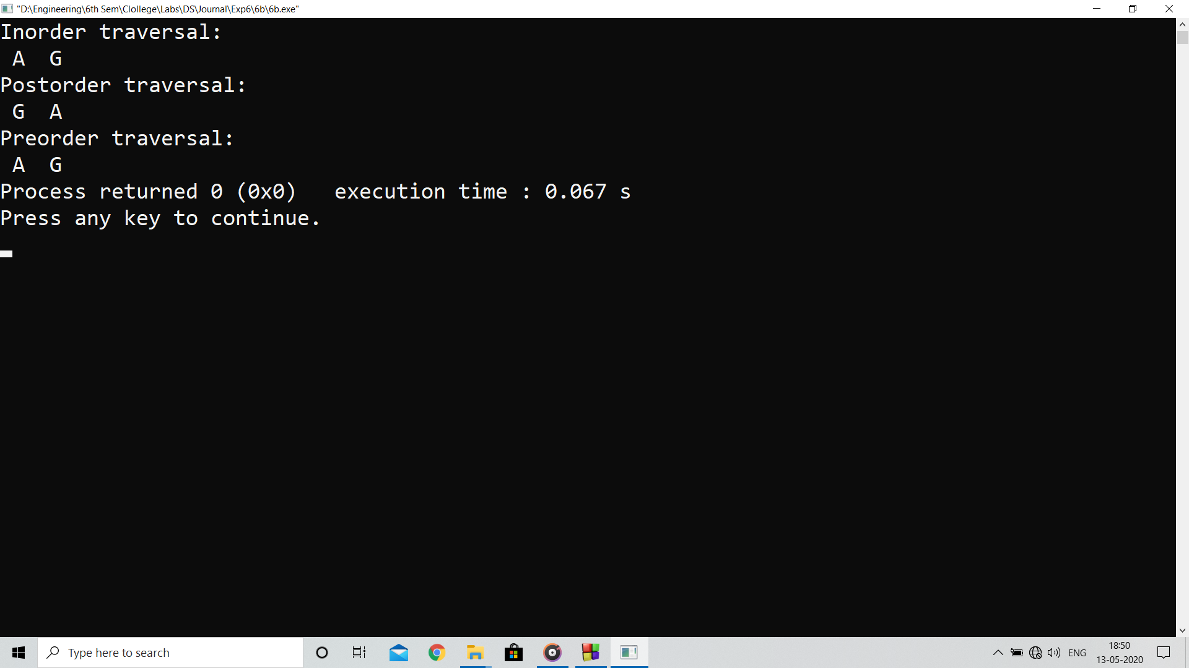

**Analysis:**

Inorder() function can give the ascending order of the values in the binary tree and preorder() and postorder() as per requirement

**Limitations:**

Inserting new element after many number of node is a costly process as insert() function travels through complete binary tree